OberlinKids Family Photo and Winter Fun Day Survey Visual Report

Event Date: Nov. 1, 2025

Demographic Information

Key Takeaway: Families are traveling from outside Oberlin to attend these events (other cities included Westlake, Elyria, Sheffield, and Lorain). It is worthwhile to consider advertising to these areas.
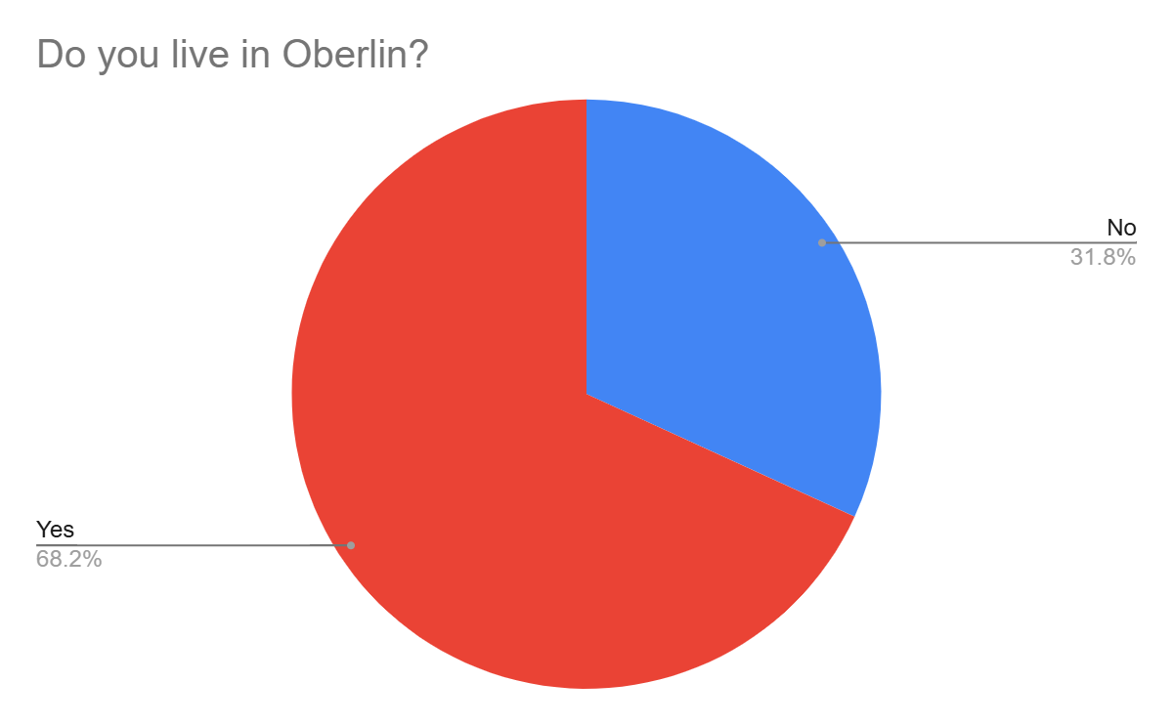
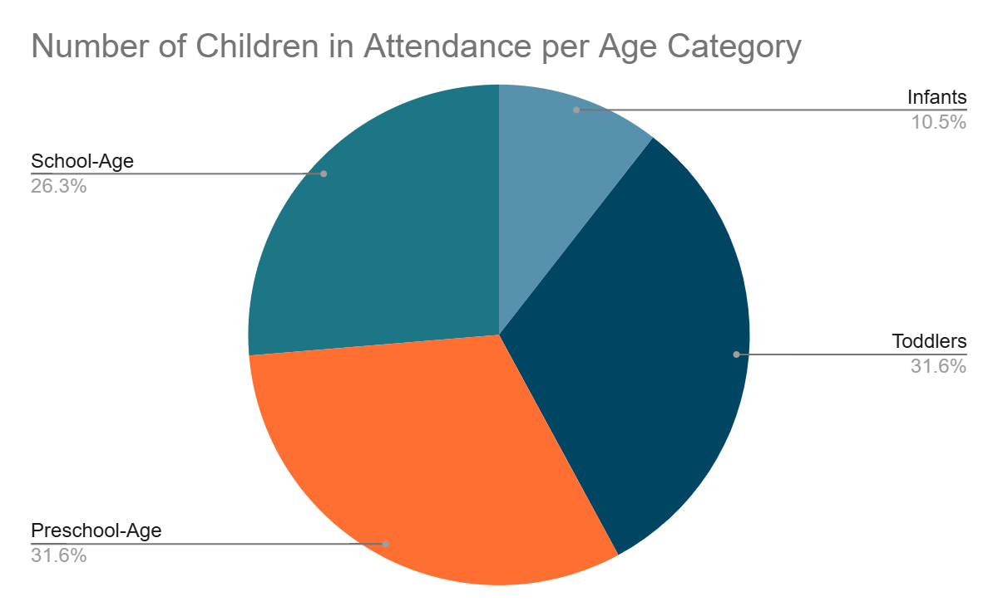
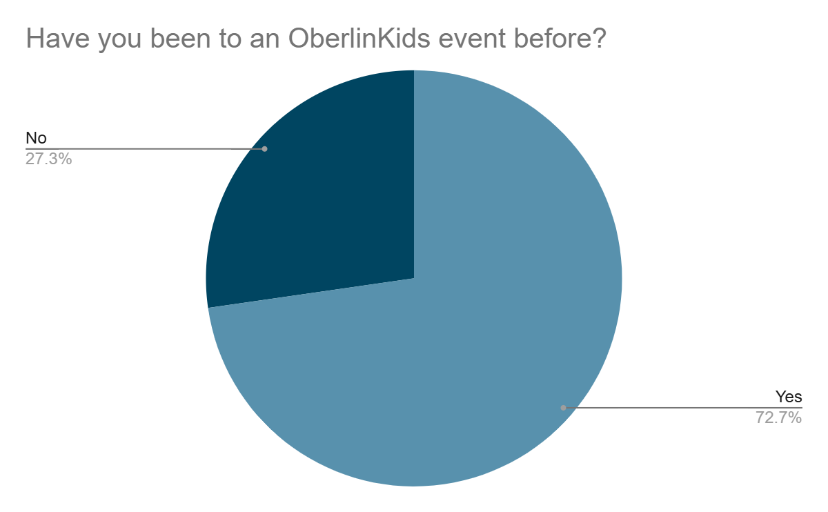
Key Takeaway: The photo-taking events attracted a large number of pre-school and school-aged children. Advertisements within the local pre-school and school systems (such as through letters home in children’s folders or emails sent out through the school) may be effective.

Reasons for and Barriers to Participation

Key Takeaways: Parents were drawn in by the activity itself, but also through advertisements, desire to show participation in the community, connections with friends of family, and enjoyment of last year's event. Annual events may be beneficial since many of this year’s participants decided to come after enjoying last year. Additionally, word of mouth plays a large role in your advertising.
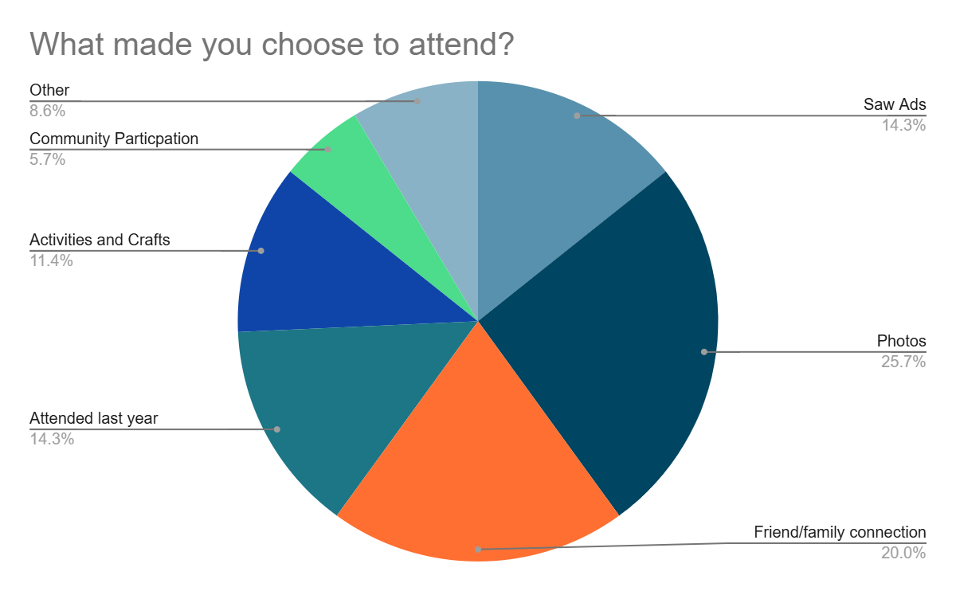
Key Takeaway: As stated above, many participants had come to this event last year. Annual or repeated events seem to be worthwhile to draw in participation of the community. This particular event drew in a good amount of new participants as well, making it a good time to get the OberlinKids name out there.

Key Takeaways: Timing of events is a significant barrier to attendance. Many parents specifically mentioned naptime (around 12-2) as a time when attending events is difficult. Other considerations include parents' daily work schedules and one parent mentioned having busy Saturday mornings. Parents also mentioned being mindful of safety, but not having concerns of OberlinKids events being unsafe.
Key Takeaways: Parents enjoy arts and crafts events and would love to see a free organized play group be created. Other ideas include:

- Night activities (for parents to have a night off)
- Library activities
- Photos events
- Reptile events
- Events where children can dress-up
- Active YYM Center Events
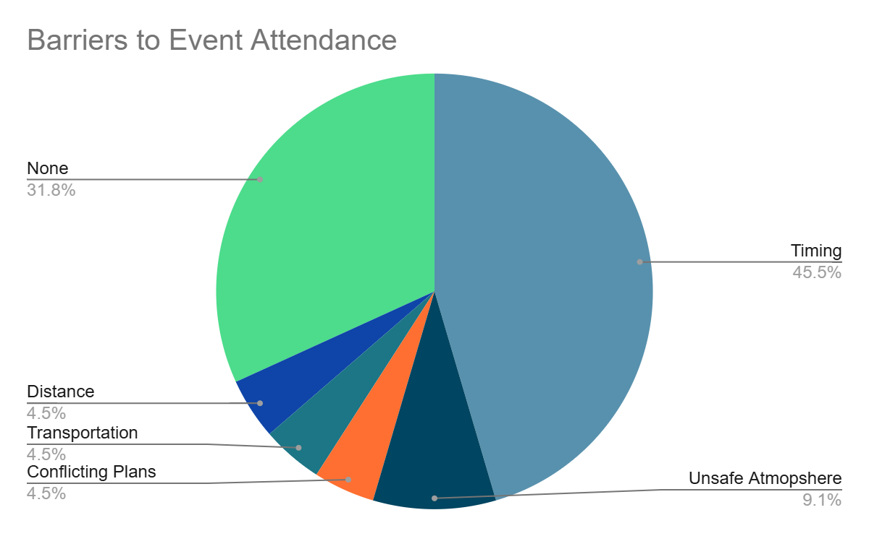
- Teamwork-centered activities
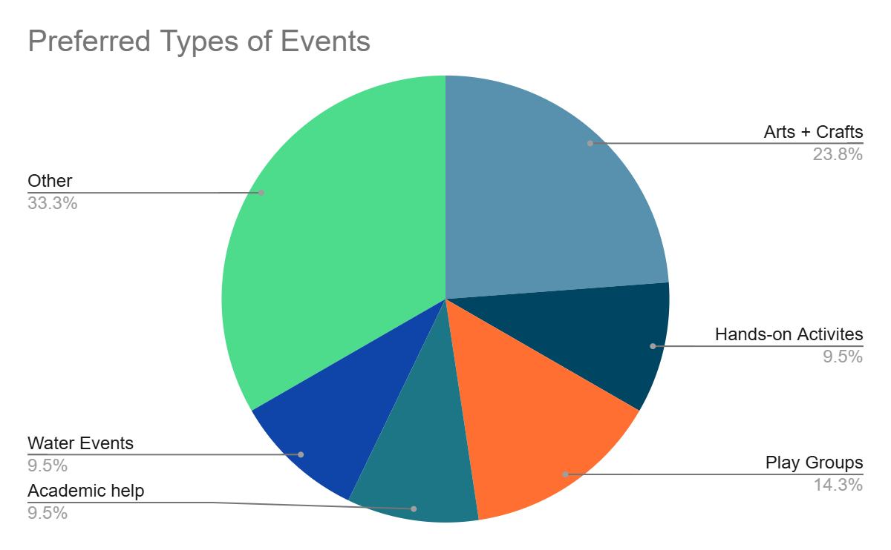
Advertising and Contacting

Key Takeaways: Social media and email are the best ways to contact the target audience. Facebook was the most frequently mentioned social media platform (mentioned 7 times) followed by Instagram (mentioned twice). Parents also mentioned the All Oberlin Page, daycare, other parents, websites, and online calendars being preferred ways of receiving information. There was no clear consensus regarding opportunities for better outreach. However, a larger social media presence and better connection with schools and daycares was mentioned more than once by parents.

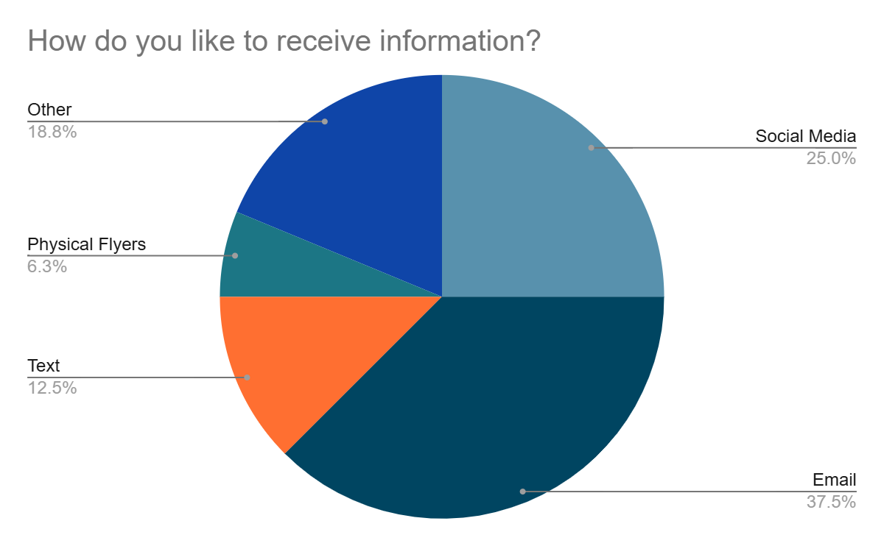
Key Takeaway: There is no strong parent group in Oberlin that was well-known among all participants, but many participants mentioned a desire to join a parent group. Below are some of the groups that were mentioned and the frequency with which they were mentioned. Some of these groups may be worthwhile to advertise directly to.

Parent Cafes | 3
Child Resource Center | 2
MomWalk Collective | 1
MovementWorks | 1
College Faculty Groups | 1

